Let us pray….Lord may these words from my lips and this mediation of our hearts be pleasing in your sight. Amen
My two favourite people and I went for a walk on my day off on Monday. To remove any doubt…that is jeanette and Ralf….we are keeping to the lockdown rules….
I would like to say a big thank you to all those who contribute to our church magazine….and especially the local walks….
We picked a walk from the magazine which took us around the outskirts of town and down to the river…..at one point we were walking on stones which were not really a path…..and at times we were on slippy and very rocky ground…..
Walking is a great time to reflect and chat about the important things in life….chocolate….puppies….motorbikes…..Jeanette often switches off when I get to motorbikes… On this occasion the beauty of the surrounding countryside drew even my attention dreaming of motorbikes to the sound of the birds, the water running past our feet and the distant rustling of the dry leaves in the wind….we are truly blessed to live in a place where we feel really welcome….we feel at home…..its nice to feel at home….and we talked about this quite a bit.
It feels like just yesterday that we were arriving in Richmond…the new curate and his wife…..and now we are just Paul, jeanette and indeed…Ralf….he even has his own social media….what will the future hold for this famous pooch and those two humans that look after him….and occasionally mother him.
We received some lovely cards and notes when we arrived….some saying, ‘new home’, others ‘welcome’ and lots of different images on the cards….Richmond, angels, flowers. If you look in the card shops at the moment…or at the online card shops…you will see cards for almost every occasion….27th July is Auntie’s day; 3rd October is Grandparents day, 21st June is Father’s day; 20th February is Pet’s day and today is Mother’s Day. I challenge you to find a relative that the card manufacturers have not already invented a day for. I am sure that very soon there will be a Next-door neighbours, friends, daughters great Aunt twice removed day.
Today apparently is Mother’s Day - unless of course you are in church, in which case vicar’s up and down the country will be reminding their congregations that today is not Mother’s day, it is Mothering Sunday, and we will come to why in a little bit.
So, what do you find on your cards from moon pig or on the shelves of Tesco? Teddy Bears? Roses? Chocolates….wine…..And what does the church of England give us as a bible reading for Mothering Sunday. John 19. Mary standing at the foot of the cross watching her son die. Anyone get a card this morning with a picture of that? I think that is unlikely.
This biblical picture of Motherhood isn’t quite the saccharin image that we see portrayed in the media or on social media…..motherhood is hard….my mum tells me regularly how hard it is to me a mother…..with the caveat that she isn’t talking about me…..obviously….I was the model son…perfect in every way.
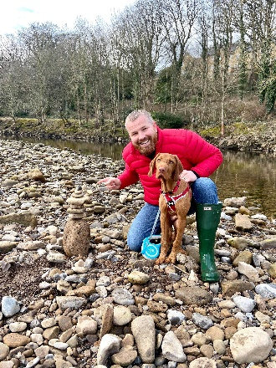
In fact….I think motherhood has a lot in common with this tower of pebbles…..balancing perilously on the edge of the pulpit…..with occasional falls and not always easy to rebuild……but then we see pictures on social media of the perfect tower of pebbles…..the perfect mother….the perfect son….the perfect daughter…….My picture here is exactly what I am talking about….look at how perfect I am…..look at my tower………what is doesn’t show is the fact that it took at least 20 attempts to built the tower…..and rebuild the tower…..and rebuild the tower……But I persevered and ….well for at least a few minutes….I succeeded……motherhood is about percevering and occasionally succeeding……being open to being mothered is much the same.

Even the most ‘anti-church’ person will have heard the story of Mary, the mother of Jesus….even if that is just the obligatory nativity play at school….but the reality is less ‘pristine blue dress and smiling baby….and more a story of pain and loss.
Mary, the teenage mum becoming pregnant when she is not yet married. Mary the young widow - we don’t know exactly when Joseph died, but we know that by the time Jesus is a grown up , Mary is maybe 45 or so, and Joseph is dead. Mary who stands at the foot of the cross watching her son die.
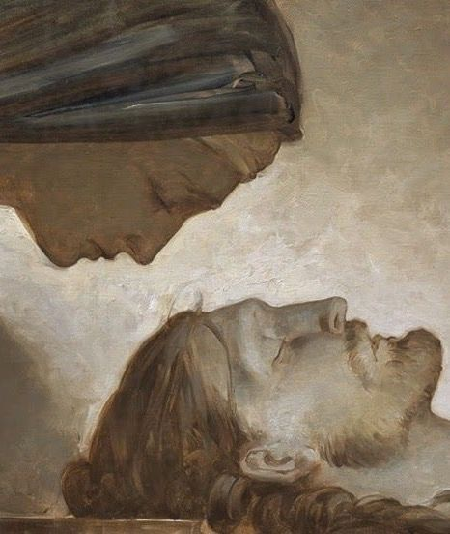
Mary - and this is an image I would really like to be able to project up for you because it is so powerful - Mary cradling her son’s lifeless body…..there is a pain in those eyes that words cannot explain.
So, the biblical idea of motherhood is as far from the images on the Mother’s Day cards as is possible….the image where nothing is ever difficult and everyone has 2.4 children, a dog, and a white picket fence.
I read an article online recently and they were speaking with mothers. One woman with three children was asked…”if you had your time over again…would you have children?....she answered….yes definitely….but I’m not sure I would have the same ones.
A single father with two children at home was also interviewed amongst the many mothers. He tried to explain what it is like to be both a mother and a father…..and he described the joy that he experiences when all the children are finally in bed….he can just be himself….not mum or dad.
In the church we are careful not to call this day Mother’s Day, because there are people in our own congregation and in every congregation who find Mother’s Day difficult.
Everyone can mother other people and everyone needs mothering.
There are those who struggle with infertility or those who never met the right person or who for whatever reasons can’t have children. There are those like Mary cradling the dead Jesus for whom today brings up thoughts of grief. There are many others for whom it is the loss of their mum that is painful.
We may not all be mothers or have mothers but all of us need mothering.
There’s a well-known saying, origin unknown, “It takes a village to raise a child,” in other words, every single one of us needs more mothering than any one mother could ever provide. And although motherhood is a unique honour and challenge, all mothering takes place within families and communities and networks of support and influence. We are a family brought together through faith….You are part of this family……You are loved……You have been entrusted to this church family….and we have been entrusted to you.
In our reading “Jesus entrusted Mary to the disciple John, but he didn’t entrust her to his brothers and sisters who were still alive. We know that he had four brothers - James, Joseph, Simon, and Judas - and some sisters who are not named. That seems a little strange. Surely one of them could have looked after their mum into old age. But Jesus doesn’t pursue that option. Why? What else is going on here?
There is something quite profound about what Mary and the disciple John represent to us here. Because here are two people who are there with Jesus at the foot of the cross, two people who believe in his mission, two people who believe in his claim to be the Son of God – the Lord and Saviour of the world. This is in stark contrast to Jesus’ brothers. In John 7:5, we are told quite starkly, “Not even his brothers believed in him.”
So it seems that what is happening here between Jesus and the two people at the foot of the Cross who believe in him, is that a new family is being created…..a family….like ours…brought together through their faith in Jesus Christ.
Verse 26 again: “Jesus saw his mother and the disciple he loved standing there; so, he said to his mother, ‘He is your son.’ Then he said to the disciple, ‘She is your mother.’ From that time the disciple took her to live in his home.”
A new family is created in the shadow of the cross. Through the blood of Christ shed for us, a new home, a new community comes to life – a new family is born……It is here, at the foot of the cross as Jesus sheds his blood and a mother embraces her son and a son embraces his mother– it is in this embrace….this very public show of Love that the church is formed!”
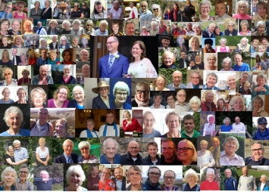
Mary is an example to all of us. As former Archbishop of Canterbury Rowan Williams puts it, “For centuries, Christians have kept coming back to the idea that what happens in Mary is what has to happen to some degree in each of us….. She says a yes so complete that her entire material life is changed by the coming of God to her; God's everlasting gift of himself that is the Son, the Word, emerges from her to begin that life which will change everything in creation. ….But WE are called to the same job, to give God room so that we may be changed, so that the eternal Word will live in us and speak and act in love to others”
I expect there are very few people who could honestly say they haven’t wished their kids were as good as their friends’ kids….or breathed a sigh of relief when the kids are in bed….peace at last…. If only my kids were better behaved then life would be perfect…..
Don’t bet on it! Mary had the perfect son in Jesus - and look how hard her life was!
Mothering Sunday, placed so near to Holy Week, reminds us that a relationship, any relationship, without pain is likely to be a relationship without love….. In fact, if we love, then we put ourselves in the very path of pain and suffering.
To love.. is to put yourself at risk, and your heart will sometimes be tested, sometimes broken. But we can’t wish it any other way, for we are made in the image of a God of love, and love, real love, costs – …and its expensive, sometimes we may have to pay for it as Mary did, with the currency of our tears.
But Jesus wants to mother us. He notices us, even in our worst moments of pain, shame, and humiliation, he is there for us. When we have our crosses to bear, he is there for us, just like Mary was for him.
Nearing the end of my talk I would like to share with you two sentences from a sermon delivered on mothering Sunday 2020 by our current archbishop of canterbury, Justin Welby. A man who has experienced great loss…. and great love in his life. He says:
All love has its source in the immeasurable, wonderful love of God. All consolation comes from God through being loved, and it comes to us abundantly so that we can give it to others.

Today, following the service, some from our church will be delivering flowers…..there are others within this church family that might call you, drop you an email or knock on your door to say hi….there many within our church who will be praying for you today….we aim…as a family…to mother those around us….not smother them….by these little acts of kindness….this expression of love….we build strong and lasting communities…just as Jesus did with his mother and the beloved disciple…..through love we create hope in a time of uncertainty….and we find god at work…driving out fear and filling the dark space with light.
Amen

